|  |  |  |
| --- | --- | --- |
| **MODULE:** 7 | **LESSON:** 1 | RATIOS, RATES, TABLES, AND GRAPHS |

A **ratio** shows a relationship between two quantities.

Ratios are **equivalent** if they can be written as the same fraction in lowest terms.

A **rate** is a ratio that shows the relationship between two different units of measure in lowest terms.

You can make a table of equivalent ratios. You can graph the equivalent ratios.

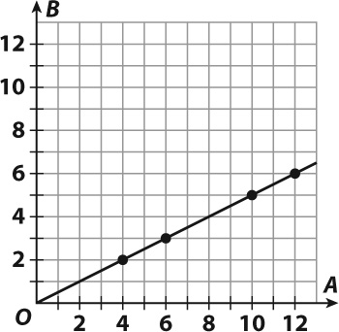

|  |  |  |  |  |
| --- | --- | --- | --- | --- |
| A | 4 | 6 | 10 | 12 |
| B | 2 | 3 | 5 | 6 |

 

 

**HELP: The data in the top row are the x-coordinates and the data in the bottom row are the y-coordinates.**